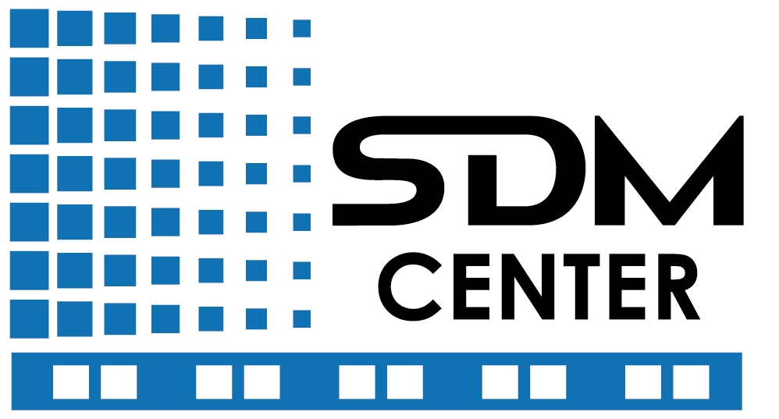
SDM Center Report

Jan 2002 - June 2006
http://sdmcenter.lbl.gov
Introduction
Managing scientific data has been identified as one of the most important emerging needs by the scientific community because of the sheer volume and increasing complexity of data being collected. Effectively generating, managing, and analyzing this information requires a comprehensive, end-to-end approach to data management that encompasses all of the stages from the initial data acquisition to the final analysis of the data. Fortunately, the data management problems encountered by most scientific domains are common enough to be addressed through shared technology solutions. Based on the community input, we have identified three significant requirements. First, more efficient access to storage systems is needed. In particular, parallel file system improvements are needed to write and read large volumes of data without slowing a simulation, analysis, or visualization engine. These processes are complicated by the fact that scientific data are structured differently for specific application domains, and are stored in specialized file formats. Second, scientists require technologies to facilitate better understanding of their data, in particular the ability to effectively perform complex data analysis and searches over large data sets. Specialized feature discovery and statistical analysis techniques are needed before the data can be understood or visualized. To facilitate efficient access it is necessary to keep track of the location of the datasets, effectively manage storage resources, and efficiently select subsets of the data. Finally, generating the data, collecting and storing the results, data post-processing, and analysis of results is a tedious, fragmented process. Tools for automation of this process in a robust, tractable, and recoverable fashion are required to enhance scientific exploration.
Our approach is to employ an evolutionary development and deployment process: from research through prototypes to deployment and infrastructure. Accordingly, we have organized our activities in three layers that abstract the end-to-end data flow described above. We labeled the layers (from bottom to top):
- Storage Efficient Access (SEA)
- Data Mining and Analysis (DMA)
- Scientific Process Automation (SPA)
The SEA layer is immediately on top of hardware, operating systems, file systems, and mass storage systems, and provides parallel data access technology, and transparent access to archival storage. The DMA layer, which builds on the functionality of the SEA layer, consists of indexing, feature identification, and parallel statistical analysis technology. The SPA layer, which is on top of the DMA layer, provides the ability to compose scientific workflows from the components in the DMA layer as well as application specific modules.

This report is organized according to the three layers: SEA, DMA, and SPA

1. Storage Efficient Access
Today’s scientific applications demand that high performance I/O be part of their operating environment. These applications access datasets of many gigabytes (GB) or terabytes, checkpoint frequently, and create large volumes of visualization data. Such applications are hamstrung by bottlenecks anywhere in the I/O path, including the storage hardware, file system, low-level I/O middleware, application level interface, and in some cases the mechanism used for Grid I/O access. This work addresses inefficiencies in all the software layers by carefully balancing the needs of scientists with implementations that allow the expression and exploitation of parallelism in access patterns.
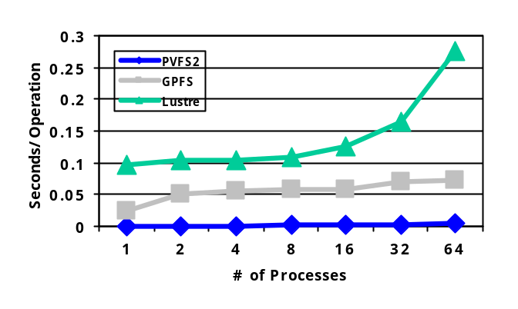
Just above the I/O hardware in a high-performance machine sits software known as the parallel file system. This software maintains the directory hierarchy and manages file data distribution across a large number of I/O components. Our PVFS2 parallel file system can provide multiple GB/second parallel access rates, is freely available, and is in use at numerous academic, laboratory, and industry sites, including the Massachusetts Institute of Technology, the University of Utah’s Center for High Performance Computing, the Ohio Supercomputer Center, Argonne National Laboratory, and Acxiom Corp.
Figure 1: PVFS2 performance for opening files using the MPI-IO interface, shown here, vastly outpaces other parallel file systems due to scalability improvements
PVFS2 operates on a wide variety of Linux platforms, making it perfect for cluster systems, and it has also been ported to the IBM Blue Gene/L supercomputer. PVFS2 incorporates key optimizations that prepare it for ultra-scale systems, including scalability optimizations that closely connect PVFS2 to MPI-IO (see Figure 1) [LRT04].
Above the parallel file system is software designed to aid applications in more efficiently accessing the parallel file system. Implementations of the MPI-IO interface are arguably the best example of this type of software. MPI-IO provides optimizations that help map complex data movement into efficient parallel file system operations. Our ROMIO MPI-IO interface implementation is freely distributed and is the most popular MPI-IO implementation for both clusters and a wide variety of vendor platforms [TGL99]. Our previous work on PVFS and ROMIO forms a solid technology base for new capabilities that address issues in scientific computing in general and in specific communities such as enhanced I/O request capabilities for PVFS and ROMIO and the Parallel netCDF (Network Common Data Form) interface.
Some applications now operate on data located across the wide area network (WAN). Unfortunately for scientists, most of the APIs that they are accustomed to using to access data stored locally will not currently operate on data stored remotely. Grid-enabling ROMIO allows existing applications to access remote data sources with no significant work on the part of scientists, significantly improving the usability of Grid I/O resources. We have implemented prototypes that are capable of accessing both Storage Resource Managers and Logistical Network data sources through the MPI-IO interface.
MPI-IO is a powerful but low-level interface that operates in terms of basic types, such as floating point numbers, stored at offsets in a file. Scientific applications desire more structured formats that map more closely to the structures applications use, such as multidimensional datasets. File formats that include attributes of the data, such as the input parameters and date of creation, and are portable between platforms, are also desirable. The Hierarchical Data Format (HDF5) interface, popular in the astrophysics community among others, is one such high level API. HDF5 uses MPI-IO for parallel I/O access as well.
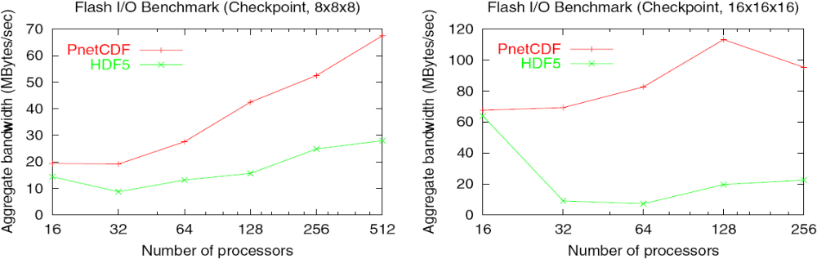
NetCDF is another widely used API and portable file format that is popular in the climate simulation and data fusion communities. Our Parallel netCDF (PnetCDF) work provides a new interface for accessing netCDF data sets in parallel. This new parallel API closely mimics the original API, but is designed with scalability in mind and is implemented on top of MPI-IO. Performance evaluations using micro-benchmarks as well as application I/O kernels have shown major scalability improvements over previous efforts [LLC+03].
Figure 1: FLASH I/O benchmark performance on the ASCI White Frost platform using the GPFS file system. In the 8x8x8 case each processor outputs approximately 8MB and in the 16x16x16 case approximately 60 MB.

Figure 2 compares the performance results of the FLASH astrophysics I/O benchmark using HDF5 and PnetCDF APIs, in which over 50% more I/O bandwidth is observed for PnetCDF. The current release of PnetCDF is version 1.0.1 and is available from http://www-unix.mcs.anl.gov/parallel-netcdf. It has been tested on a number of platforms, including Linux clusters, SGI Origin, Cray X1E, NEC SX, IBM SP, and BlueGene/L. Language supports are provided for C and Fortran. The self-test suite from Unidata netCDF package has been ported to validate against single-process results using PnetCDF APIs. In addition, a new parallel test suite has also been developed to validate the results from a various parallel access patterns.
Current PnetCDF users come from several major research centers, including:
- The FLASH application team from ASCI/Alliances Center at the University of Chicago
- The Center for Atmospheric Chemical Transport Models (LLNL)
- The Scientific Data Technologies group at NCSA, developing I/O components for the Regional Ocean Model System (ROMS)
- The ASPECT center (ORNL)
- The Portable, Extensible Toolkit for Scientific Computation (PETSc) team (ANL)
- The PRogram for Integrated Earth System Modeling (PRISM) at C&C Research Laboratories, NEC Europe Ltd.
- The Earth System Modeling Framework (ESMF) at the National Center for Atmospheric Research (NCAR)
Our earlier works made considerable contribution in caching techniques for very large files and datasets typically encountered in the area of high performance data intensive computing. In particular we showed that disk caching techniques, used for staging very large files from either tape storage or other alternate replica locations, onto local disks for direct file accesses during computations, have different characteristics than the caching techniques in virtual memory paging and web caching. We defined an appropriate metric termed the average cost per reference, for comparing various cache replacement algorithms in this contest. We show through analytical derivation that the best replacement policy is one that evicts the candidate with the least cost beneficial function _{i}(t), at the instant in time t. This is referred to as the LCB-K replacement policy. The formula for computing _{i}(t) for a replaceable file i in cache was derived as,
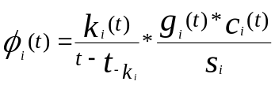
where k_{i}(t) denotes the number of references made to file i up to a maximum of K, 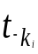denotes the time of k^{th} backward reference to file i, g_{i}(t) is the cumulative references to the file over its active period, and c_{i}(t) is the estimated cost of caching the file if not in disk. Results of a comparative study LCB-K with other methods such as LRU, LRU-K, GDS (or Greedy Dual Size), etc., are shown in Figures 3a and 3b for synthetic and real workloads respectively. The details may be found in [OOS02, OtSh03]. Further work on caching combined the replacement policies with file access scheduling for optimal cache loading. The result of this work, referred to as OptCacheLoad, combines optimal scheduling with cache replacement policy. This produces excellent response times for data intensive jobs, compared with first come first serve (FCFS) scheduling policy, under limited cache sizes. Figures 4a and 4b also show these for synthetic and real workloads respectively. The details are presented in [ORS03].
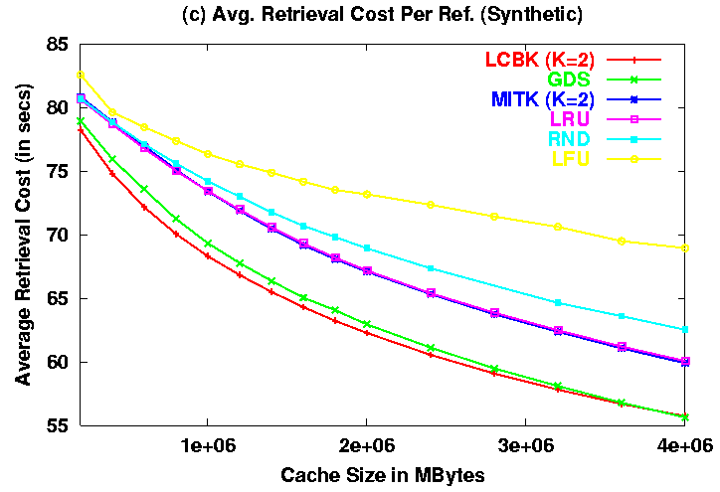
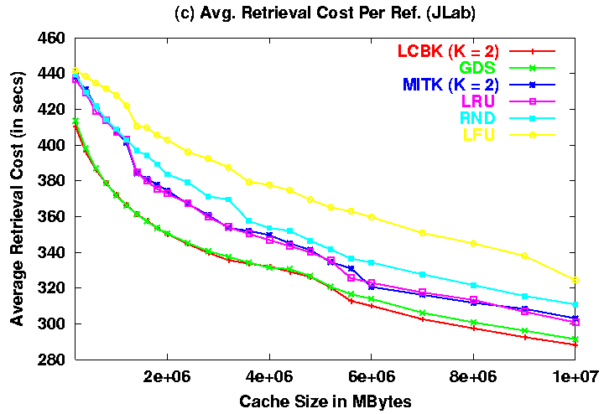

Figure 3: Comparison of average cost per retrieval for various cache replacement algorithms
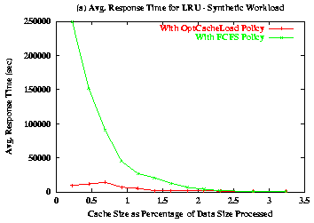
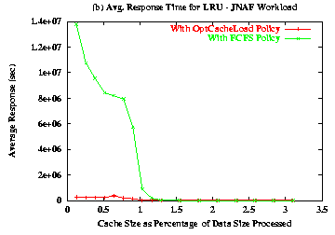

Figure 4: Average response times of jobs serviced using OptCacheLoad and LRU replacement

2. Data Mining and Analysis

Using FastBit indices for Data Analyses
Summary
The most important piece of searching software that we have developed under SDM center funding is the FastBit indexing package. FastBit is a tool for searching large read-only datasets. It organizes user data in a column-oriented structure that is efficient for on-line analytical processing (OLAP), and utilizes compressed bitmap indices to further speed up query processing. Analyses have proven that the compressed bitmap index used in FastBit is theoretically optimal for one-dimensional queries. Compared with other optimal indexing methods, bitmap indices are superior because they can be efficiently combined to answer multi-dimensional queries whereas other optimal methods cannot. In this section, we briefly describe the searching capability of FastBit, then highlight two applications that make extensive use of FastBit, namely Grid Collector and DEX.
Introduction
It is a significant challenge to search for key insight in the huge amount of data being produced by many data-intensive science applications. For example, a high-energy physics experiment called STAR is producing nearly a petabyte of data a year and has accumulated many millions of files in last five years of operation. One of the core missions of the STAR experiment is to verify the existence of a new state of matter called the Quark Gluon Plasma (QGP) [BGS+1999]. An effective strategy for this task is to find the high-energy collisions that contain signatures unique to QGP, such as a phenomenon called jet quenching. Among the hundreds of millions of collision events captured, a very small fraction of them, maybe only a few hundreds contain clear signatures of jet quenching. Efficiently identifying these events and transferring the relevant data files to analysis programs are a great challenge. Many data-intensive science applications are facing similar challenges in searching their data.
In the past few years, we have been working on a set of strategies to address this type of searching problem. Usually, the data to be searched are read-only. Our approach takes advantage of this fact. Since most database systems (DBMS) are built for frequently modified data, FastBit can perform searching operations significantly faster than those DBMS.
Conceptually, most data can be thought of as tables, where each row of the table represents an object or a record, and each column represents one attribute of the record. To accommodate frequent changes in records, a typical DBMS stores each record together on disk. This allows easy update of the records, but in many operations, the DBMS effectively reads all attributes from disk in order to access a few that are relevant for a particular query. FastBit stores each attribute together on disk, which allows one to easily access the relevant columns without involving any other columns. Even though an update may take longer to execute, but because a typical update operation usually add a large number of objects, the extra overhead introduced by vertical partitioning is negligible. In the database theory, separating out the values of a particular attribute is referred to as a projection. For this reason, using column-wise organized data to answer user queries is also known as the projection index [OQ1997].
Each column of a table is a dimension of the data. Many scientific datasets have tens or hundreds of dimensions; they are called high-dimensional data. User queries usually involve conditions on several attributes; they are known as multi-dimensional queries. To answer multi-dimensional queries on high-dimensional data, it is well known that the projection index performs better than most indexing methods including B-Tree. Since FastBit uses column-wise organization for user data, without any additional indices it is using the projection index, which is already very efficient. Our indexing technology further speeds up the searching operations. We have analyzed our bitmap index and showed it to be optimal for one-dimensional queries [WOS2002, WOS2004, and WOS2006]. Some of the best indexing methods including B+-tree and B*-tree have this optimality property as well. However, bitmap indices are superior because they can be efficiently combined to answer multi-dimensional queries.
FastBit Indices
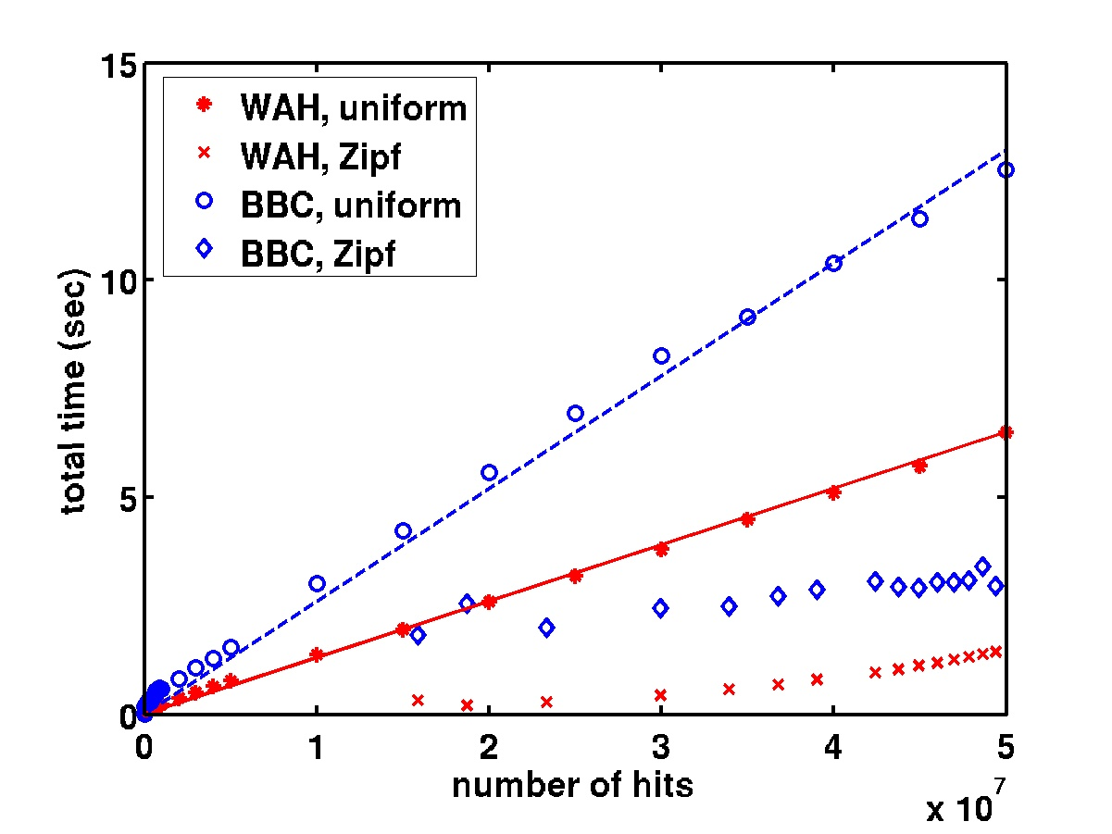
Figure 1: The time required to answer a range query with a WAH compressed bitmap index is a linear function of the number of hits in the worst case.
The key to the effectiveness of the FastBit searching software is a special compression scheme called the Word-Aligned Hybrid (WAH) code. This compression scheme enables FastBit to compress the bitmap indices to modest sizes [WOS2004, WOS2006]. At the same time, it enables common operations on the compressed bitmaps to be extremely efficient [WOS2002, WOS2004]. The performance measurements and the analyses are published in well-known conferences and journal in the database community [WOS2002, WOS2004, and WOS2006].
Through extensive analyses [WOS2004, WOS2006], we are able to prove that the time required by a WAH compressed index to answer a range query is a linear function of the number of hits in the worst case. Through the analyses, we also identified that the worst case is achieved with uniform random data. Figure 1 plots the query response time against the number of hits. It is easy to see that the time to answer range queries on uniform random attribute is indeed a linear function of the number of hits. For attributes that do not have uniform distribution, the query response time is short than those need to answer queries involving uniform random attributes. In Figure 1, we also plotted the time used by the next most efficient compression scheme for bitmap indices, the Byte-aligned Bitmap Code (BBC). It is clearly that WAH compressed indices always use less time.
A very significant advantage of compressed bitmap index over commonly used B-tree variants is that bitmap indices can be easily and efficiently combined to answer multidimensional queries. Figure 2 shows the time required by different indexing methods to answer some random multi-dimensional range queries on a set of data from the STAR experiment. In this figure, the horizontal axes are the query box sizes, which are defined to be the fraction of rows that are expected to be the hits. It is clear from this figure that WAH compressed bitmap indices are usually ten times faster than the next most efficient method.
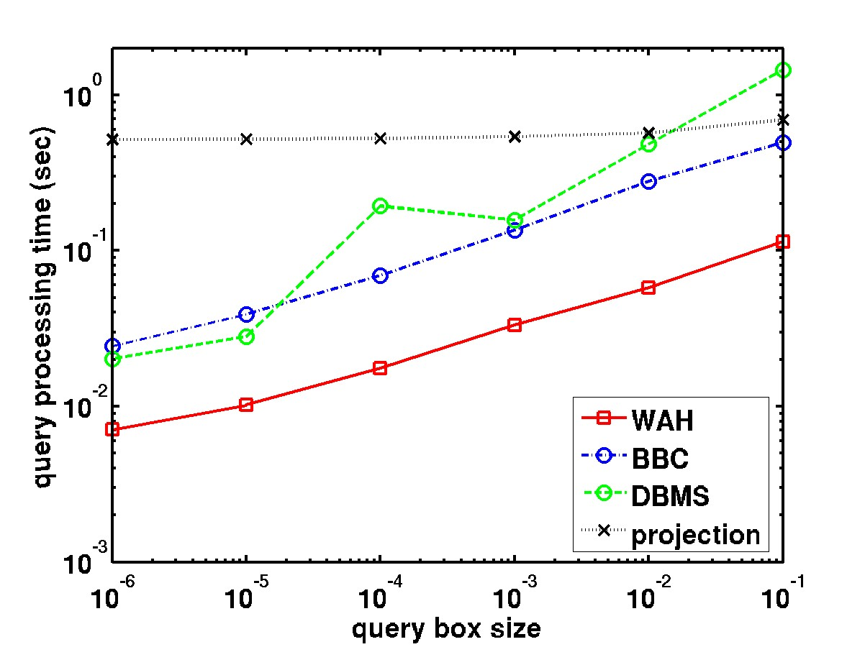 | 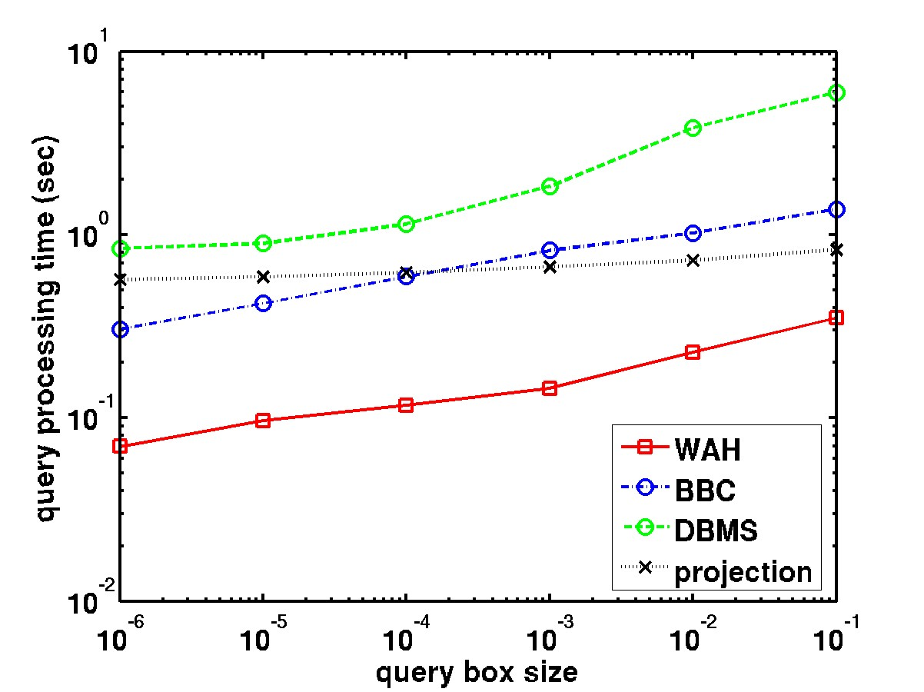
Figure 2: Time required to answer some random multi-dimensional range queries using different indexing methods.
Grid Collector
Grid Collector is a client-server system that plugs into the STAR analysis framework to provide a new ways for users to select events of interest for analyses. Figure 3 shows the overall architecture of the system. It uses the FastBit software to implement an Event Catalogue for all events produced in the STAR experiment. It also enables analyses of archived data and remote data. This capability of performing large-scale analysis of data across the data Grid was recognized with a Best Paper Award from International Supercomputer Conference 2005 [WGL+2005].
DEX
Our work on feature tracking in combustion simulation data [WKS+2003] has led to the development of a set of Connected Component Labelling algorithms for data from regular meshes as well as image data. This has further led into fruitful collaborations with the Visualization group at LBNL combining VTK and FastBit techlogies [SSBW2005, SSWB2005], and applied to efficient network traffic analysis [Sto+05]. DEX is shorthand for Dexterous Data Explorer. It is a visualization system for scientific data produced on regular meshes. Figure 4 shows two sample images produced by DEX. This work was recognized no only by the database community [SSBW2005] by also by the visualization community [SSWB2005].
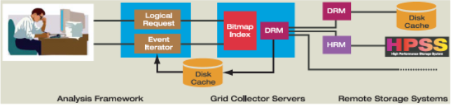
Figure 3: The architecture of Grid Collector for STAR.

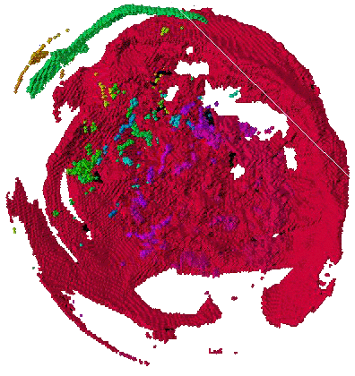 | 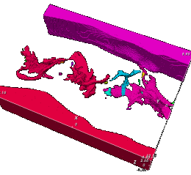
Exploding supernova | Methane jet flame
Figure 4: Two sample images produced by DEX on simulation data.

High Performance Statistical Computing

Motivation
Terascale computing enables simulations of complex natural phenomena, on a scale not possible just a few years ago. With this opportunity, comes a new problem – the massive quantities of data produced by these simulations. However, answers to fundamental questions about the nature of the universe remain largely hidden in these data. The goal of this work is to provide a scalable high performance statistical data analysis framework to help simulation scientists perform interactive analyses of these raw data to extract knowledge. To achieve this goal we developed an open source parallel statistical analysis package, called Parallel R, that lets scientists employ a wide range of statistical analysis routines on high performance shared and distributed memory architectures without having to deal with the intricacies of parallelizing these routines.
“Parallel R” for Parallel Statistical Analysis with R
Present data analysis tools such as Matlab, IDL, and R, even though highly advanced in providing various statistical analysis capabilities, are not apt to handle large data-sets. Most of the researchers’ time is spent on addressing data preparation and management needs of their analyses. Our goal has been to scale up the existing data analysis software to meet the requirements posed by application scientists. Under Parallel-R project [S05], we have tried to address the aforementioned issues using an open source R statistical package [VSR05]. As with any other widely used data analysis software, R is also not designed to work with huge datasets and performs poorly in handling the same. With Parallel-R, we have identified data-parallel and task-parallel strategies through which the existing data-analysis system can be infused with certain parallel computation techniques to meet some of the challenges in analysis of huge data-sets. Under Parallel-R project we have designed, developed, benchmarked and released two add-on software libraries for R, namely RScaLAPACK and taskPR. These packages are currently distributed across 24 countries through R’s CRAN network. The RPMs for the same packages have been built and distributed by RedHat, SUSE, and Quantian Linux distributions.
Enabling Data-Parallel Statistical Analysis with RScaLAPACK. With RScaLAPACK we have replaced serial linear algebra problem solving routines that used LAPACK library, with its corresponding parallel algorithms provided by the ScaLAPACK library. A single RScaLAPACK function call carries out a complete cycle of data-parallel computation to obtain the solution for a requested linear algebra problem. Furthermore the function interface remains similar to its serial predecessor (see Accomplishments in section 3.2.3). In addition, the performance benchmarks carried out on the RScaLAPACK functions revealed that they are scalable in terms of both the problem size and the number of processors. A consistent increase in the speedup with the increase in the number of processors used in RScaLAPACK function execution can be observed; further increase in the speed up with the increase in the input data size was also observed (Figure 1). With three update releases following the original release of RScaLAPACK, we have tuned the supported functions to perform well in diverse environments. A technical paper discussing the RScaLAPACK’s architecture and related performance gains achieved was published, and presented at the 18th International Conference on Parallel and Distributed Computing, 2005 [SYBK05].
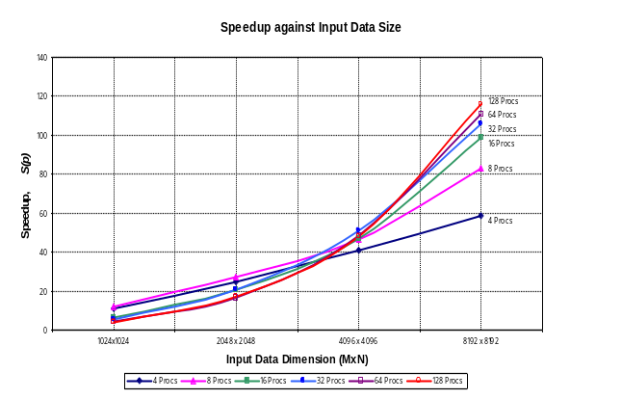
Figure 1. Speedup for parallel RScaLAPACK’s sla.solve() over serial R’s solve()for different sizes of input data.
Providing a Middleware for Task-Parallel Statistical Analysis with taskPR. With taskPR package we identified a means using which the existing serial code written in R, could be parallelized. The taskPR system provides a mechanism to detect the out-of-order independent R tasks and intelligently delegates each task to the remote worker processes, to evaluate them in parallel.
Figure 2: Serial and parallel versions of proteomics protein quantification code.
...
for (i in 1:length(chroList)) {
currResult [i] = Rratio(filename=chroList[i]);
}
...
...
PE ( for (i in 1:length(chroList)) {
currResult [i]= Pratio(filename=chroList[i]);
} )
...
Serial Version
Parallel Version
Figure 2, depicting the snapshot of a serial R code in biology demonstrates the ease with which a serial code could be parallelized. Further, a significant speedup was recorded for these parallelized protein abundance ration calculations with taskPR (Figure 3).

Applying Parallel R across Various Scientific Applications
Novel Feature Extraction for Quantitative High-Throughput Proteomics. The cellular activities of biological organisms are carried out by a complex network of thousands of proteins. To characterize this network, biologists can perturb an organism’s growth with genetic or environmental treatments and then observe how the organism responses with the adjustment of its different proteins’ abundance. Quantitative proteomics is an emerging high throughput technology that enables biologists to measure the abundance change of thousands of proteins in the treatment organisms relative to the reference organisms. The results of quantitative proteomics would give a global view of the protein network’s response to a treatment. However, the quantitative proteomics has posed unprecedented informatics challenges: massive and complex data management system and development of novel algorithms for very noisy data.
The mass spectral data are generated in heterogeneous propriety data formats, such as Xcalibur, MassLynx and Analyst. The raw data in different formats are then converted into an open mass spectral data format, mzXML. The mass spectral data, combined with the genome sequences, are used for peptide identification and protein identification. With the identification results, the mass spectral data are then used for peptide quantification and protein quantification.
We have collaborated with Dr. Robert Hettich’s GTL proteomics team to automate the data processing pipeline and integrated all modules for quantification (shown in blue in Figure 4) into the ProRata program [PHM+05, PKT+05, PKT+06, PKM+06]. The data visualization is especially important for quantitative proteomics, as biologists often need to manually explore the data and verify the results. ProRata is equipped with a sophisticated interactive graphical user interface to provide the data visualization capability (Figure 5). The two core modules in the ProRata program, peptide quantification and protein quantification, are powered by the novel algorithms that we developed for processing the noisy data. Principal component analysis (PCA) is used for peptide quantification. The first principal component captures the signal component in the data and the second principal component captures the noise component. The PCA algorithm not only de-noises the data, but also gives an estimation of the signal-to-noise ratio (S/N) of the data. The estimated relative abundance for peptides is then combined for protein quantification with maximum likelihood estimation (MLE). By probabilistically weighing the peptides with their S/Ns, the MLE algorithm gives a more accurate point estimation of the protein relative abundance than the averaging method used in previous programs. More importantly, the MLE algorithm also estimates the confidence interval for the proteins’ relative abundance. The confidence interval of a protein’s relative abundance captures the quantification precision for the protein. The confidence interval estimation is especially important in proteomics, in that the thousands of proteins are quantified at vastly different precisions.

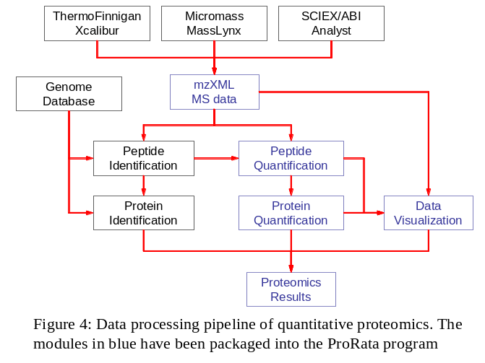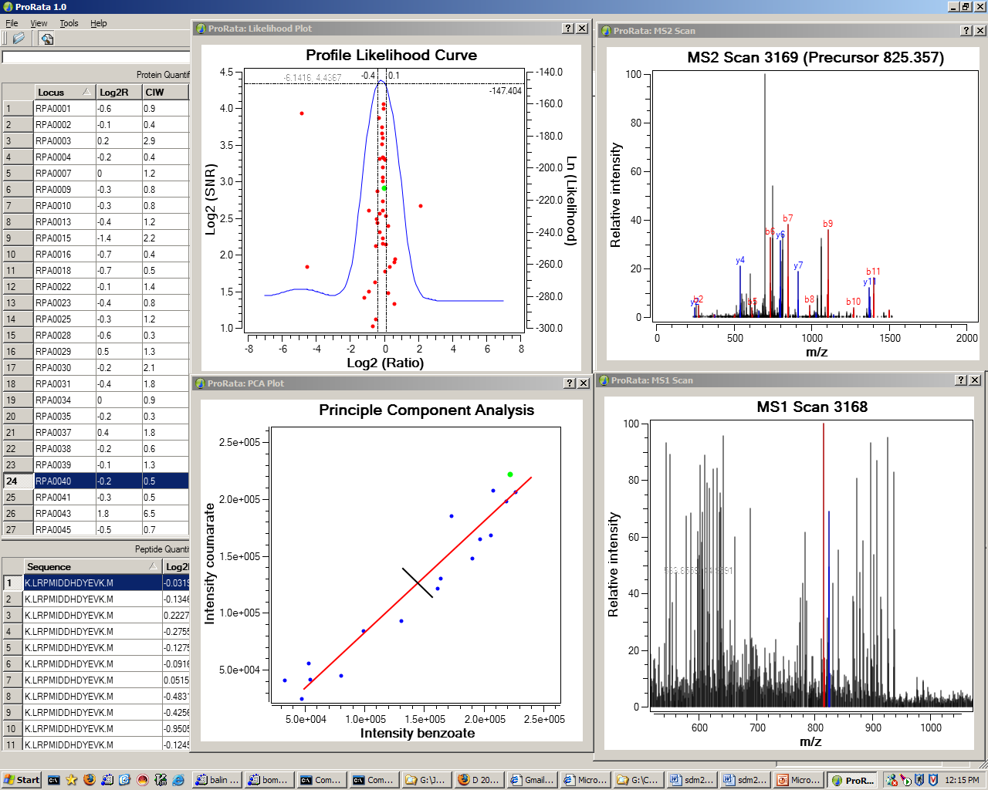
Figure 5: The screenshot of the ProRata’s graphical user interface for data visualization in quantitative proteomics

Managing proteomics data is a huge challenge especially in the context of keeping pace with the high-throughput data generation rate of modern mass spectrometers. In ORNL GTL mass spectrometry group, two gigabytes of data are generated per day per instrument and there are four instruments running seven days per week. A forthcoming DOE GTL Proteomics Facility will have hundreds of mass spectrometry devices. Some experiments run for 1 day and some other experiments run for 10 days, depending on the number of experimental conditions and the number of replicates. For example, with two biological replicates and two technical replicates (typical run), there will be four days of instrument time, which would generate about 8 Gb data. There are usually 12 raw files in a MudPIT experiment. But as the data pass through the pipeline, the type of files and the number of files changes. The SEQUEST generates million s of OUT files per 24 hours, which are combined into 1 file by DTASelect. ProRata generates thousands of xic.xml files, which are also processed to 1 file. The R implementation of the ProRata’s algorithms has been parallelized with taskPR has greatly enhanced the data processing throughput (Figure 3).
Parallel Analyses of Climate Data. We are collaborating with the SciDAC ORNL climate team including Dr. John Drake, Dr. Marcia Branstetter and Dr. Auroop Ganguly to provide them with a capability to efficiently handle terabyte climate simulation data spread across multiple netCDF files. Currently, due to the size and complexity of the data sets, even performing a simple statistical procedure on the selected data involves laborious work and poses a great challenge.
In performing uni-variate and multi-variate dependence analysis in climate extremes, they work with the climate data spanning 230 years starting from year 1870 to 2100. The climate extremes refer to extremities in the climate variables like, heat waves, cold waves, rainfall etc. By studying the extremes researchers understand the global climate pattern. Extreme value statistics that quantifies the stochastic behavior of a process at unusually large (or small) values is used for this purpose. Currently, NCAR's Extremes Toolkit (extRemes) [GKY05], an interactive program for analyzing extreme value data using the R statistical programming language, is used by the climate researchers for their analysis purposes.
One of the problems that the climate researchers at ORNL face was the interactive selection and extraction of a required set of data spanning over thousands (18,000) of netCDF files. Each file measuring about 393 MB contain data for around 64 different climate data variables like precipitation rate (PRECC), each such variable is dependent on one or more of over 10 dimension values like, latitude (lat), longitude (lon) etc. Further, each file contains data for 20 successive time-steps with each having a periodic difference of 6 hours. At the initial stage of our collaboration, we have been able to apply parallel R libraries to parallelize the process of reading specific data of interest from multiple netCDF files in parallel, given the details of the dataset that needs to be extracted using the API as shown in Figure 6.
The linear speed-up performance gains were observed in reading the data in serial as compared to reading them in parallel using Parallel-R libraries.
output <- getTimeSeries ( Variable= 'PRECC', TimePeriod = c(startTimePeriod,
endTimePeriod), lat = c(startLatitude, endLatitude),
lon = c(startLongitude, endLongitude))
Figure 6: Parallel R API for climate data extraction.

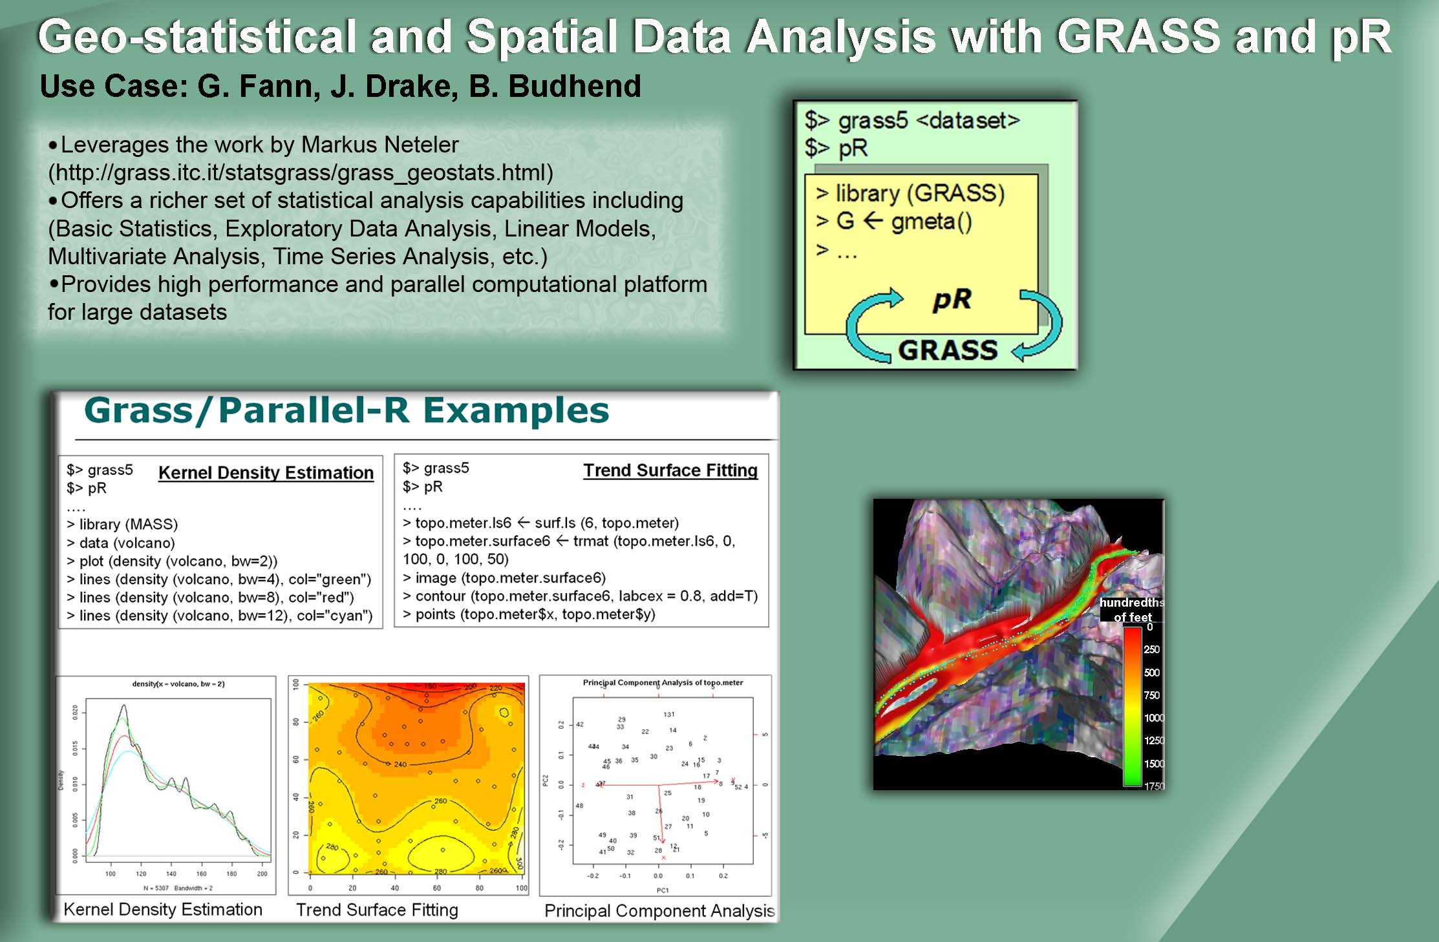
Bringing Parallel R to Geographical Information Science (GIS). We worked closely with Dr. Budhendra Badhuri, Dr. George Fann and Dr. John Drake at ORNL to improve their data analysis and visualization workflow. To address their large scale data analysis needs we developed a software bridge to integrate ParallelR with GRASS GIS application tool (Figure 7). GRASS (Geographic Resources Analysis Support System) is a raster/vector GIS, image processing system, and graphics production. It contains over 350 programs and tools to render maps and images on monitor and paper; manipulate raster, vector, and sites data; process multi spectral image data; create, manage, and store spatial data. However, it was lacking advanced statistical data analysis capabilities that were required to analyze GIS and climate data. The integration of GRASS with Parallel R brought both advanced statistical analysis for large-data and image rendering capabilities in a single environment.
Figure 7: Example usages of Grass and Parallel R.

Feature selection in scientific applications

Understanding changes in the global climate is challenging, since simulated and observed data include signals from many sources. To make meaningful comparisons between climate models, and to understand human effects on global climate, we need to isolate the effects of these different sources. For example, volcano eruptions and El Nino and Southern Oscillation (ENSO) variations both influence global temperatures, but recent volcanic eruptions coincided temporally with large ENSO events, making it difficult to separate the volcano effect from the ENSO effect. We collaborated with Dr. B. D. Santer from the Program for Climate Modeling and Intercomparison (PCMDI) at LLNL to investigate solutions that combine the existing techniques of principal component analysis (PCA) and independent component analysis (ICA). Neither method in isolation solved our problem adequately, but we obtained much improved results by first using PCA to reduce the dimension of the data, and then applying the more compute intensive ICA to the reduced data. Figure 1 displays three independent component basis functions obtained by applying our method to observational data from the National Center for Environmental Prediction. We determined the bases to represent the ENSO, the North Atlantic Oscillation (NAO), and the volcano components in the data. Figure 2 shows in red the monthly time series component estimates corresponding to the three bases presented in Figure 1. The blue curves display the ENSO 3.4 index, the NAO index, and an idealized volcano signal signature, correspondingly. The excellent match between the two series in the top panel of Figure 2 indicates that our approach isolated successfully the ENSO component. The agreements between the estimated NAO and volcano components, and their corresponding idealized signatures, are not quite as high, but they are scientifically significant nonetheless.

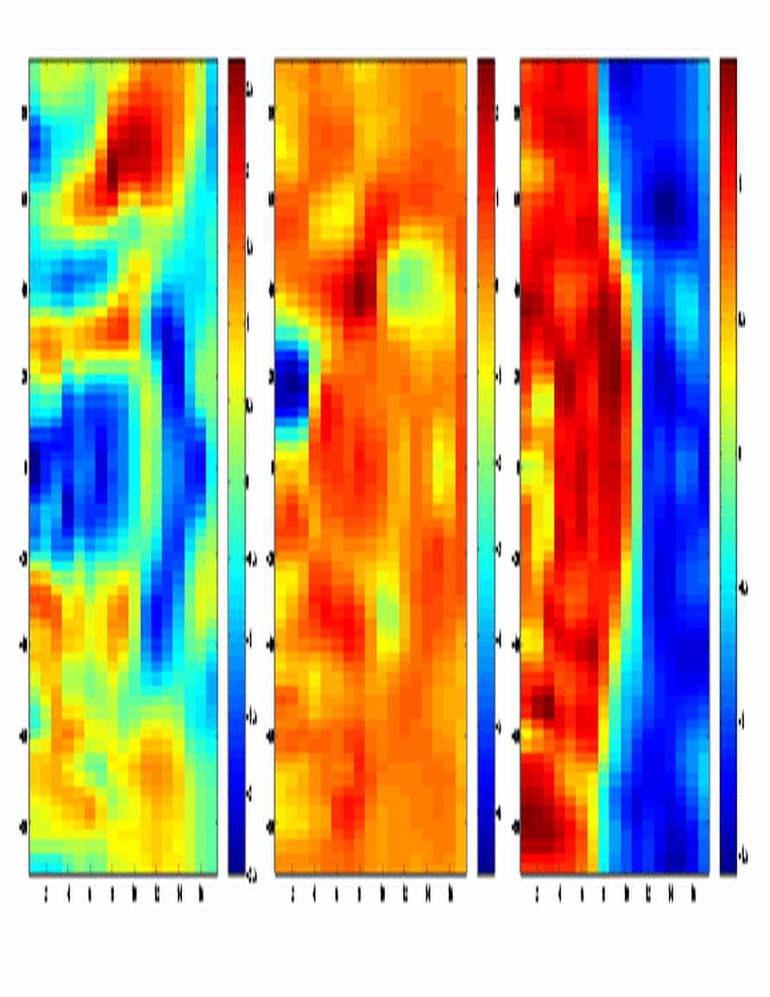

Figure 1. The three ICA bases representing the left) ENSO, middle) NAO, and right) volcano components.

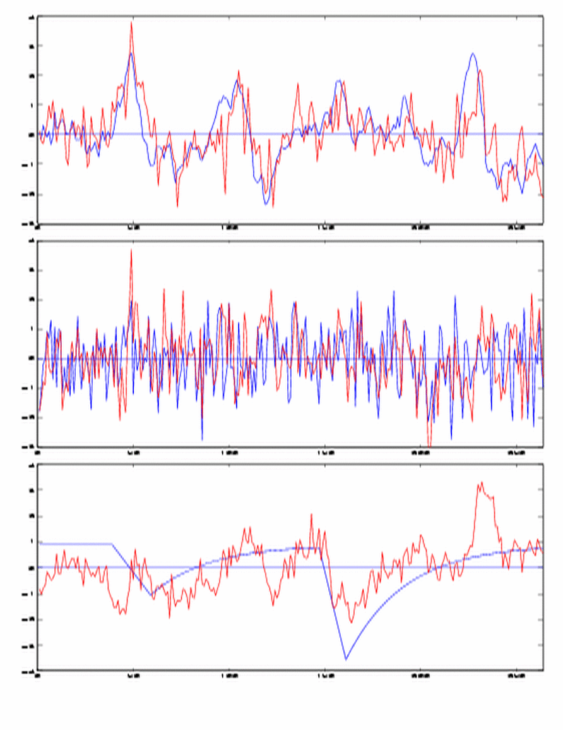

Figure 2. The three monthly time series corresponding to the three bases shown in Figure 1: the top) ENSO, middle) NAO, and bottom) volcano components. Red lines are our estimates. Blue lines indicate the ENSO 3.4 index, the NAO index, and an idealized volcano signal, respectively.

Following the success of our work with climate data, we were approached by scientists at General Atomics analyzing the large volumes of data being collected from the DIII-D Tokamak. They are interested in determining which of the numerous parameters being measured are relevant to the presence of edge harmonic oscillations (EHOs). EHOs are associated with a “Quiescent H-mode” of operation. H-mode operation is the choice for next-generation tokamaks, as it offers superior energy confinement, but it comes at a significant cost due to effects of edge localized modes (ELMs), which could cause rapid erosion of divertor components in tokamaks. During quiescent operation there are no ELMs. EHOs appear to provide an enhanced particle transport at the edge of the plasma that provides the needed density control.

Currently, EHOs are identified mostly by visual means using the Fourier spectrum of the data from a magnetic probe. If an experiment seems to contain EHOs, data from other sensors (plasma velocity and the distance between the plasma edge and the tokamak wall) are consulted to verify the existence of the EHO. A summer student developed a program that implements the rules that the scientists have derived from their visual observations to identify EHOs. The program uses a sliding time window to analyze the data and assigns an "EHOness" value to each time window. The program seems to perform satisfactorily, but the results cannot be used to explain why or when EHOs appear.

Our goal was to help the scientists identify which of the numerous measurements is related to the occurrence of EHOs in their data. Each experiment lasts for about six seconds and data from numerous sensors are recorded and stored in a combination of MDSPlus and home-grown ptdata files. We collaborated with Dr. Keith H. Burrell of General Atomics to combine domain knowledge with our feature selection techniques to identify the key features. Dr. Burrell identified approximately 40 candidate variables, which we extracted from the database into text files with the format used by our tools. We faced some challenges in this task. (1) The only existing interface to the database is for IDL (Interactive Data Language), so existing IDL programs were modified to output data in the format we use. (2) The data from multiple sensors is not sampled at the same rate or may start or end at different points in time, and thus the data must be registered. (3) Some of the variables of interest have to be calculated from the raw data.

We extracted the features that describe approximately 500 experiments that have been analyzed (visually) by Dr. Burrell. His analysis will be useful to validate the results. We also did some additional preprocessing to remove entries with missing values, with feature values which appeared to be outliers, and to remove possibly irrelevant entries near the beginning and the end of experiments where some feature values appear very noisy. We then applied several dimension reduction techniques (partially funded by SciDAC-1) and found that we were able to identify EHOs with a low error rate using just a few of the features (See Fig. 3). Thus, a physicist can focus on a few variables instead of the original 40, in their attempts to understand EHOs.

The software for dimension reduction and for anomaly detection in streaming data has since been licensed to General Atomics for further use in their work. In addition, our work on the DIII-D data caught the attention of fusion scientists at Princeton Plasma Physics Laboratory (PPPL), which led to an on-going collaboration on the analysis of Poincaré plots and the research and development of software for blob tracking.
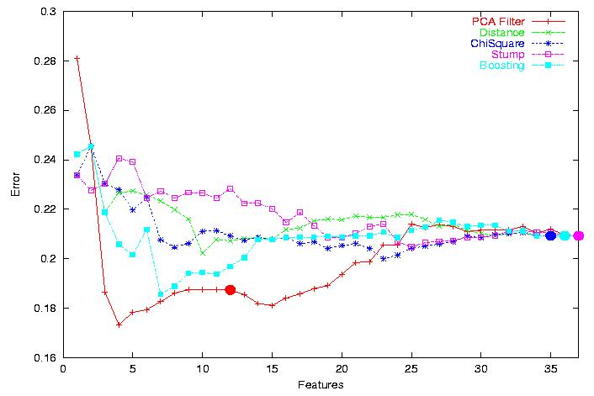

Figure 3. The performance of different dimension reduction techniques, with the features on the x-axis, and the error rate for the identification of EHOs on the y-axis .

Details of our analyses and publications are at www.llnl.gov/casc/sapphire/pubs.html.

3. Scientific Process Automation (SPA)

3.1 Background and Motivation
Science in many disciplines increasingly requires data-intensive and compute-intensive information technology (IT) solutions for scientific discovery. Scientific applications with these requirements range from the understanding of biological processes at the sub-cellular level of “molecular machines” (as is common, e.g., in genomics and proteomics), to the level of simulating nuclear fusion reactions and supernova explosions in astrophysics. A practical bottleneck for more effective use of available computational and data resources is often in the IT knowledge of the end-user; in the design of resource access and use of processes; and the corresponding execution environments, i.e., in the scientific workflow environment of end user scientists. The goal of the Kepler/SPA thrust of the SDM Center is to provide solutions and products for effective and efficient modeling, design and execution of scientific workflows.
The scientific community now expects on-demand access to services which are not bound to a fixed location (such as a specific lab) and fixed resources (e.g., particular operating system), but which can be used over (mobile) personal access device of a scientist (e.g., laptop or a PDA or a cell phone) [NSF03, DOE04]. The need is for environments where application workflows are dramatically easier to develop and use (from art to commodity), thus expanding the feasible scope of applications possible within budget and organizational constraints, and shifting the scientist’s effort away from data management and application development to concentrating it on scientific research and discovery (Figure 1).
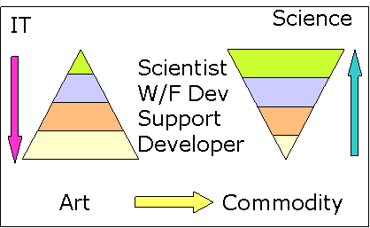
The key to the solution is an integrated framework that is dependable, supports networked or distributed workflows, a range of couplings among its building blocks, a fault-tolerant data- and process-aware service-based delivery, and ability to audit processes, data and results. Key characteristic of such a framework and its elements are [CL02,LAB+06]: Reusability (elements can be re-used in other workflows), substitutability (alternative implementations are easy to insert, very precisely specified interfaces are available, run-time component replacement mechanisms exist, there is ability to verify and validate substitutions, etc), extensibility (ability to readily extend system component pool, increase capabilities of individual components, have an extensible architecture that can automatically discover new functionalities and resources, etc), customizability (ability to customize generic features to the needs of a particular scientific domain and problem), and composability (easy construction of more complex functional solutions using basic components, reasoning about such compositions, etc.)
Figure 1

3.2 Accomplishments
As part of original SciDAC SDM Center, the Scientific Process Automation (SPA) thrust has made several significant contributions to improve scientific workflow technology, leading to the adoption of scientific workflows within the DOE community:
- Co-founded the Kepler project. Based on extensive evaluation of multiple, competing technologies (e.g., [Cha02], [ABB+03], [LAG+03]), we co-founded the Kepler project [Kep06, LAB+05]; a multi-site open source effort to extend the Ptolemy system [Pto06] and create an integrated scientific workflow infrastructure. We have also started to incorporate the SCIRun [SCI06] system into our environment, to better handle the needs of tightly-coupled and visualization-intensive workflows.
- Deployed workflows in multiple scientific domains. We have worked closely with application scientists to design, implement, and deploy workflows that address their real-world needs (e.g., [Cha02], [PAL+03], [MVB+04], [Bha05], [KBB+05]). In particular, we have active users on the SciDAC Terascale Supernova Initiative (TSI) team and within the LLNL Biotechnology Directorate. The success of these deployments has resulted in the SPA team being approached to participate in several SAPs.
- Developed specialized actors. We designed and implemented many of the actors commonly needed by scientists. For example a web service actor, which supports invocation of distributed web serves and a secure shell actor supporting remote task execution.
- Extended existing capabilities. We have added asynchronous service-based process status tracking, as well as a simple provenance tracking capability to the Kepler infrastructure. While significant work is required to fully-implement these capabilities for general workflows, the current implementations meet our customers’ near-term requirements.
- Initial deployment infrastructure. We have developed a web-based deployment infrastructure for distributing our system, including updates and patches, to users (available on-line at https://www-casc.llnl.gov/sdm/). This infrastructure includes documentation automatically extracted from the actor class definition.

Over the first three years of the project, the SPA team (Georgia Tech, LLNL, NCSU, and SDSC) has focused on engineering and developing a loosely coupled scientific workflow environment that uses data and computational resources accessible both locally and remotely over the network. In the last two years, we (LLNL, NCSU, SDSC, UC Davis and U of Utah) worked on integrating loosely and tightly coupled workflows, and understanding and implementing production level workflows for a number of users. The current version of the SPA/Kepler workflow construction and support system provides a range of capabilities, from those that support low to medium intensity dataflows (e.g. bioinformatics workflows) to those that support large data-intensive workflows (e.g., large-scale astrophysics and fusion simulations). Significant progress was possible over the last five years, because we heavily leveraged existing technology instead of “re-inventing the wheel” where that was not necessary. We initially conducted a comprehensive survey of existing technologies and open source tools, and developed a few small evaluation prototypes of the possible solutions. This allowed us to mitigate the risks and make crucial decisions in an informed way and on time. We have now a very vibrant development effort, not least because we have adopted an excellent workflow construction and execution engine code base (the Ptolemy II system from UC Berkeley) that was designed to be extensible with reusable, substitutable, customizable and composable components (actors), and was provably sufficiently reliable and maintainable. We then built our own extension libraries for the system and co-founded Kepler³, and open source workflow support environment that has since been adopted by a fairly broad scientific workflow community. Since then, the Kepler community has grown into a vibrant new source of innovation, extension and solutions that directly benefit our projects. We were very successful in selecting the right pilot scenario (promoter identification workflow discussed below) and a very capable and willing collaborating domain scientist (Dr. Coleman). In addition, through a collaborative effort within the Kepler project, we have successfully brought in external developers in a cross-project open source development activity.
Figure 1
Detailed information about this project and its results can be found in the publications and reports produced (see publications list).

3.2.1 SPA/Kepler Workflow Framework and Environment (Ptolemy II/Kepler)
The whole workflow process can be encapsulated in the (currently Ptolemy-based) workflow framework to allow easy task definition/description, process initiation, progress tracking, collection of process metrics, and process repetition – all from a variety of end-user platforms (Windows, Unix, MacOS). The method for this formal recording of the process is available, and when applied to TSI or Fusion Simulation Project (FSP) or other workflows it eases exchange of the workflow information, as well as its modification, understanding, and verification and validation. This work required development of a library of scientific SPA “actors” that - when designed properly generalize and are thus re-usable for definition and management of other scientific workflows. Figures below show the design view of the several implementations operational workflows. The SPA prototypes and production workflows were demonstrated at a number of occasions, including the Supercomputing Conferences 2002,2003, 2004 and 2005.
One of the hallmarks of this project is a rich library of Kepler/Ptolemy actors – both general and domain specific system components and extensions developed by SPA – these include:
- custom actors for a number of bioinformatics and TSI web services and provenance;
- a generic web service actor for seamless plug-in of any standard web service [AJL+04];
- a web service harvester to the system, which, after pointing the system to a web page or repository of web services, ingests all available service operations at once and automatically creates a library of web services to be used by the scientist.
- data transformation and data movement actors were added to the system to handle many different data-type sources (e.g., [Oot04], [OVV03a]);
- a browser/user-interaction actor was developed that allows the workflow designer to include standard browser inputs (e.g., forms, but also dynamic Javascript features, clickable images etc.) and outputs (e.g., HTML tables) within the user’s workflow;
- a command-line actor (for interaction with local platform commands), and a set of remote access actors (e.g., ssh actor);
- Additional enhancements to the system were made in collaboration with external contributors to the Kepler initiative: A generic design actor (a SEEK contribution) allows a scientist to develop and document a design of a scientific workflow without necessarily having an implementation for the individual tasks/actors. SEEK colleagues also provided a 10-times faster build environment for Kepler as compared to the standard Ptolemy II build. A database source actor (a GEON contribution) allows connecting and querying any JDBC data source as part of the scientific workflow; and so on.

3.2.2 Workflows
Over the last two to three years we leveraged our experience by partnering with several additional and very successful SciDAC projects that helped us extend our system to data-intensive tasks and to tightly-coupled workflows. Specifically, additions to the project were interactions with Terascale Supernova Initiative (TSI), Fusion Simulation Projects (FSP), and SCIRun. In addition to end-users from TSI (Drs. Blondin and Swesty) and FSP (Dr. Klasky), the project welcomed a member from the SCIRun team. This added to our experience with large-scale tightly-coupled scientific data-flows as well as integration with applications available through CCA. Active cooperation with the TSI team was especially fruitful since their workflows served not only as a template for high-intensity interactions but also to recognize and explore next-generation issues and improvements such as detachable workflows, fault-tolerance, process tracking and provenance, workflow security, and service-based asynchronous solutions.
Figure 2 shows the “science driver” that was used in the first phase of the project and its translation into Kepler framework: A starting point for discovery is to link genomic biology approaches such as microarrays with bioinformatics to identify and characterize eukaryotic promoters. We call this the promoter identification workflow or PIW. To clearly identify co-regulated groups of genes, high throughput computational molecular biology tools are first needed that are scalable for carrying out a variety of tasks such as identifying DNA sequences of interest, comparison of DNA sequences, and identification of transcription factor binding sites, etc. Some of these steps can be executed by querying web-accessible databases and computation resources. However, using web sources "as-is" to enact scientific workflows required many manual and thus time-consuming and error-prone steps. It was thus desirable to automate scientific workflows such as the PIW as much as possible. A number of information technology and database challenges have to be overcome. In the initial stages of the project, we had intensive interactions with our domain science drivers (Dr. Matt Coleman) to understand the requirements of the specific PIW workflow. Only after having built an initial “custom prototype” did we have sufficient information for the detailed design of the actual workflow. We also investigated the available workflow technologies and user environments for design and executing scientific applications, and eventually settled for the Ptolemy II system (see SPA publications for details).
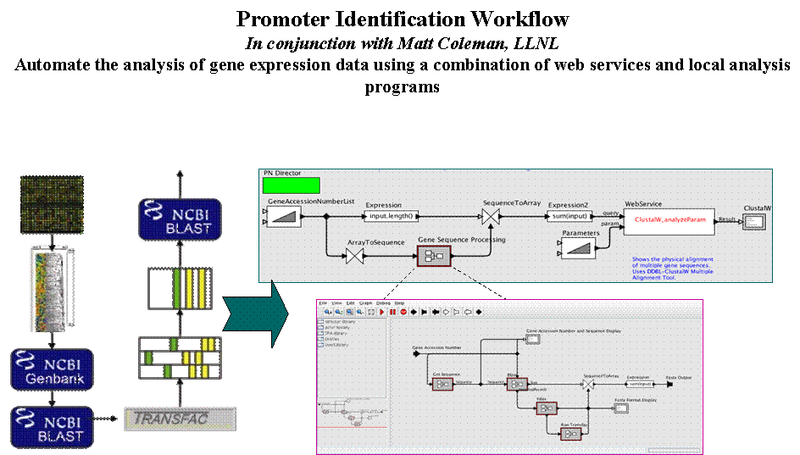
We then extended this approach of one-to-one interactions with additional science driver groups, specifically TSI and FSP, and built first custom, then more general workflow support solutions. Results have been excellent and very well received. Figures 3 and 4 illustrate respectively translation of TSI (Dr. Swesty) and FSP (Dr. Klasky) workflows into Kepler. Of course, behind each of the steps shown in the figures are a number of more sophisticated and details processes that perform actual computations, move, aggregate, and transform the data, and deliver the final end-user product. In the context of TSI, basic scientific challenges center around the development of a standard model of supernovae core collapse and related processes. In the case of FSP the science is about understanding efficiency and stability of fusion solutions and processes.
Figure 2
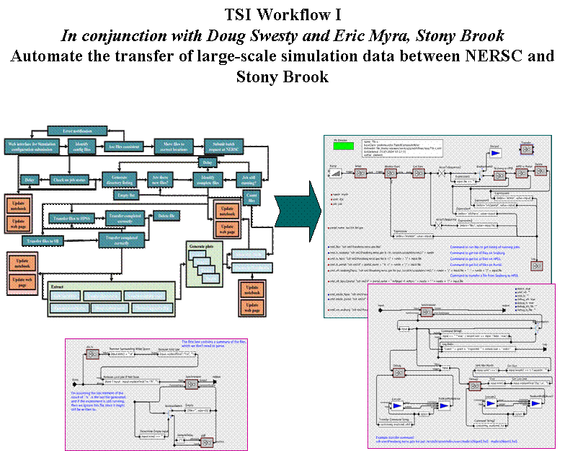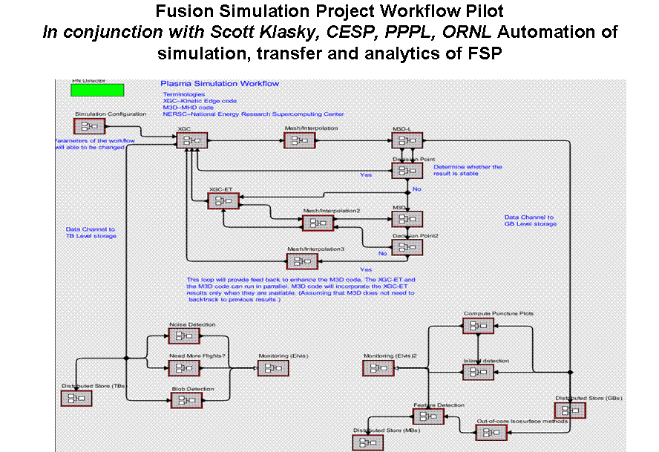
Figures 3 and 4 – TSI (Swesty) workflow (left) and pilot for an FSP workflow (Klasky).
Underlying challenges related to simulations, data analysis and data manipulation include scalable parallel numerical algorithms for solution of large, often sparse linear systems, flow equations, and large eigen-value problems, running of simulation on supercomputers, movement of large amounts of data over large distances, collaborative visualization and computational steering, and collection of appropriate process and simulation related status and provenance information. This requires interdisciplinary teams of astrophysicists, nuclear physicists, fusion physicist, applied mathematicians, computer scientists, etc. The general underlying “template” (and the potential role-model for future workflow construction and management “wizards”) is amazingly similar: large-scale parallel computations and steering (hundreds of processors, gigabytes of memory, hours to weeks of CPU time), data-movement and reduction (terabytes of data), visualization and analytics (interactive, retrospective, and auditable). An abstraction of this and its Kepler translation are illustrated in Figures 5 and 6 (Blondin workflows). In creating successful abstractions of the TSI and FSP workflows we have identified a number of next generation challenges. Some of these challenges were collected in recent publications. ([ABB+05, AKA05].

3.3 Next Set of Challenges
Significant work still remains to be done before scientific workflow technology reaches ‘utility’ state of ease of use expected by the majority of application scientists. The challenge is to generalize the lessons learned so far, and to extend the framework support for whole scientific discovery domains. The work we are proposing will make another set of significant advances in this direction by developing additional automation that will yield flexible, dependable, extensible, customizable, scalable, and (re-)usable workflows for application scientists. While the focus is on workflows that require high-performance computing (HPC) support, the technology is applicable across the spectrum, from hand-held PDAs to HPC.
For example, end-users need to trust the workflow solution before they would depend on it. This requires a high confidence level that the “mechanics” of their workflows will operate as they expect, it requires some run-time indicators that this is the case, it requires some information about the history of the computations and results, (for example Figures 7 to 10) and it requires an environment where workflow modifications are easy, and operation of workflows can happen in both synchronous and asynchronous mode. It is obvious that the next generation solution will span many scientific workflow domains and layers. Hence, workflow framework and solutions must be functional, dependable (reliable) [e.g., VR03, Col04. Moul05, Vou05], scalable, domain-sensitive, verifiable (including semantics), efficient and user friendly (at many levels), and must provide for both workflow status assessments at run-time and data provenance, as well as debugging options. The scope ranges from infrastructure development and deployment of a highly dependable framework and components for solutions, to data provenance and “dashboarding”, to high-end semantic-level end-user assistance and workflow verification and validation.
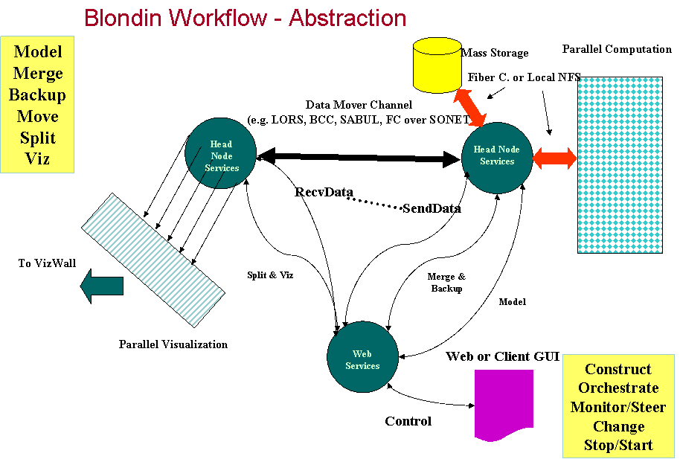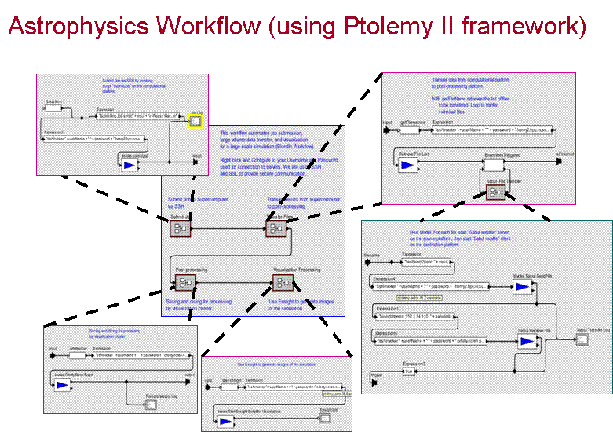
Figures 5 and 6 – TSI (Blondin) workflow abstraction with asynchronous service-based control and tracking (left) and synchronous pilot for the same workflow (Blondin).
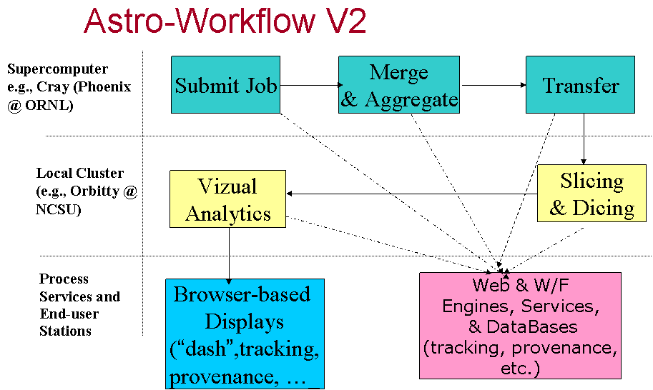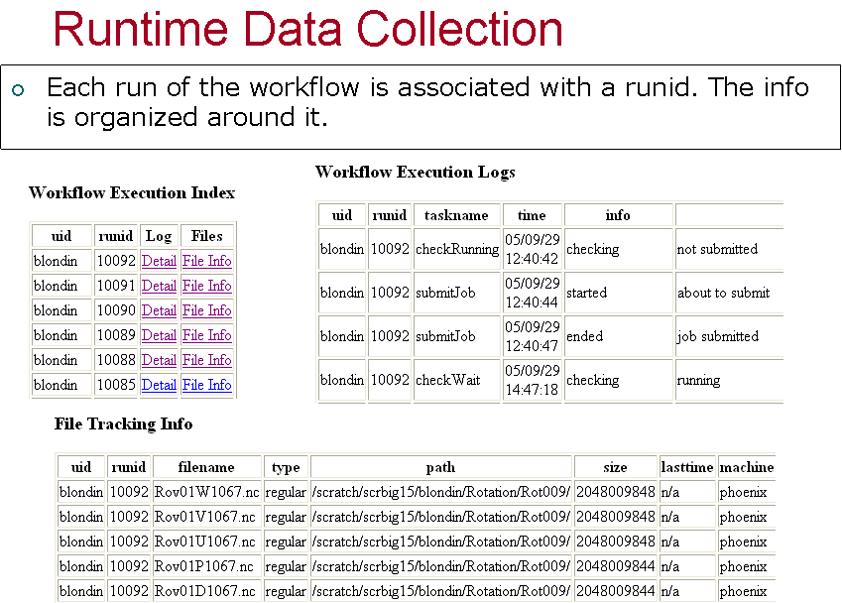

Figures 7 and 8 – Layering approach to implementation of detachable TSI (Blondin) workflows with run-time monitoring and provenance (left), and example of a run-time information being collected on the current pilot.
As already mentioned, despite our significant successes, much work remains before scientific workflow technology reaches state where it is a commodity tool, easily used by application scientists. There are three major, customer-driven, areas:
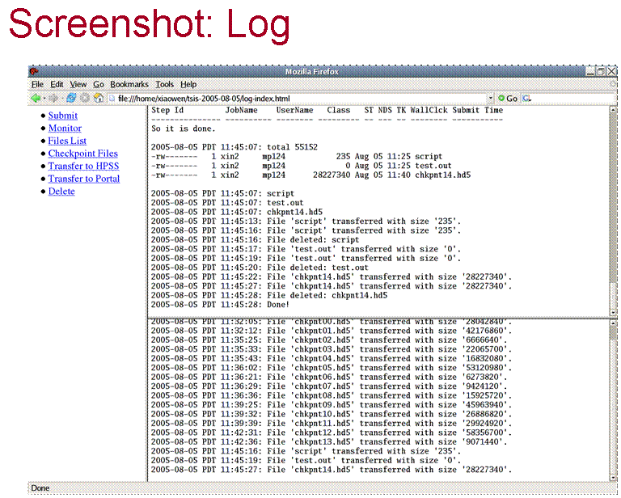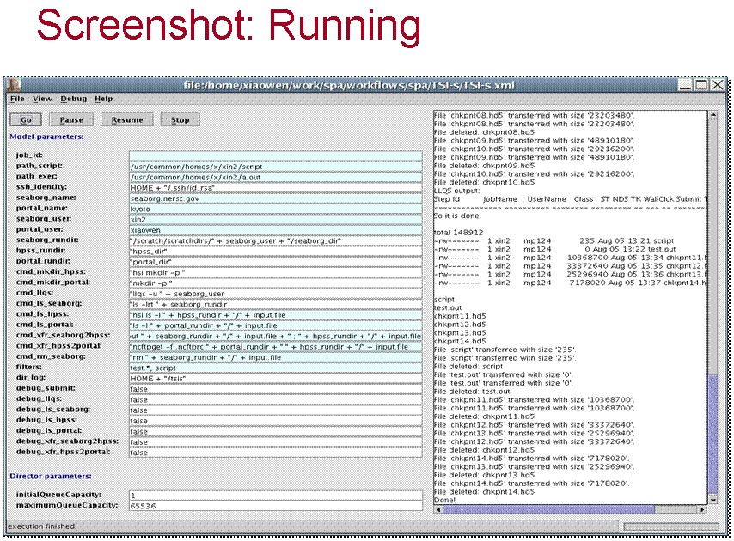
Figures 9 and 10 – Run-time logs and tracking information taken from TSI (Swesty) workflow implementation.
- User interactions. We will extend the current user interfaces to support web-based portals, domain specific “dashboards”, template workflows for common tasks, and generalized actors that perform common, high-level functions while removing the specific implementation details from the user environment. For example, as illustrated in our pilot implementations related to TSI workflows (Blondin related in Figures 7 and 8 and Swesty related in Figures 9 and 10), end-users do want to track progress the workflows are making. In order to do that effectively, we propose to extend our framework to enable both. Workflow construction and operation “wizards” are in the plan too.
- Data collection and management. We will extend the current system to support data provenance, workflow provenance, and fault tolerances. In terms of data that we plan to collect, part of the needs are illustrated in Figures 5 through 8. We conducted several reliability and fault-tolerance studies and plan to incorporate the most promising mechanisms into the next generation SPA/Kepler framework.
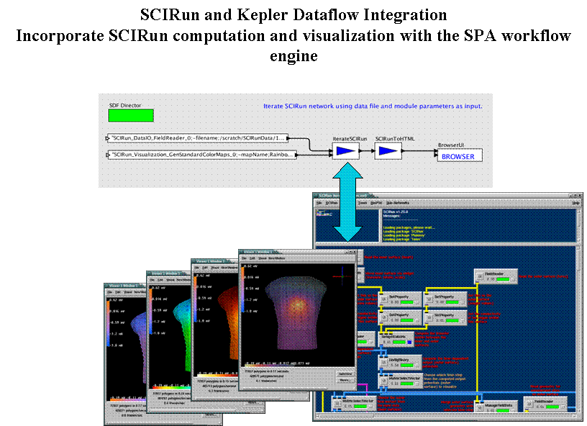
- Workflow infrastructure. It is interesting to note that one of the “next generation” issues is seamless integration of loosely coupled sub-workflows (e.g., Kepler based) with more tightly coupled ones (e.g., within problem solving environments such s SCIRun). Our pilots (Figure 11) indicate that such coupling is feasible. By applying SCIRun, we plan to make the visualizing process much more of an interactive plug-and-play environment. This will allow end-users to stay in the domain of the tools they are used to (e.g., Ensight) while making the process much more robust and efficient. SCIRun provides tools for modeling, computation, analysis and visualization of scientific datasets. Another desirable feature is interoperability with other potential workflow framework. Hence, will plan to extend our framework to support easy bridging between tightly-coupled and loosely coupled workflows; to provide distributed, asynchronous workflow execution and monitoring; and to improve workflow construction and deployment infrastructure (e.g., via “wizards”).
Figure 11. Pilot of a bridging solution.

Another name that may characterize the data more accurately is Writing-Once Read-Many (WORM).
http://ptolemy.eecs.berkeley.edu/ptolemyII/
http://kepler.ecoinformatics.org
http://software.sci.utah.edu/scirun.html
http://www.phy.ornl.gov/tsi/
The Terascale Supernova Initiative (TSI, http://www.phy.ornl.gov/tsi/) is a DoE/OS/SciDAC sponsored “multidisciplinary collaboration of one national lab and eight universities to develop models for core collapse supernovae and enabling technologies in radiation transport, radiation hydrodynamics, nuclear structure, linear systems and eigenvalue solution, and collaborative visualization.”

